# ED Dashboard Configuration Questions

## 1 – LOS Component

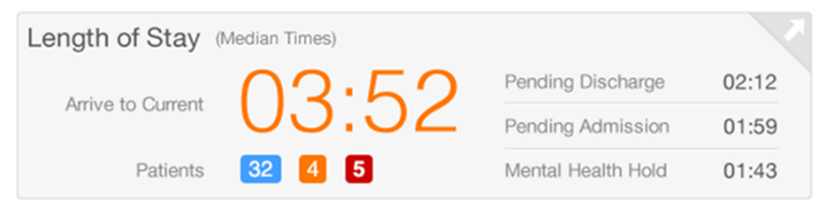

Displays the median LOS for the patients in the department from arrival to current according to the target times set for Admission/Discharge. Prearrival are excluded from this calculation. Patients below target minute time appear in blue and above this time appear in Orange. Patients above Critical minute time appear in Red.

By default, median time for pending Discharge and Pending Admission patients are displayed separately. An additional category is available for configuration to track another set of patients, such as Psych/Mental Health holds or pending transfer.

Q.1.1 What is the target minute for the LOS in ED?

Q.1.2 What is the Critical minute for LOS in ED?

Q.1.3 (optional) What is the extra category to display in LOS?

## 2 – Turnaround Times Component

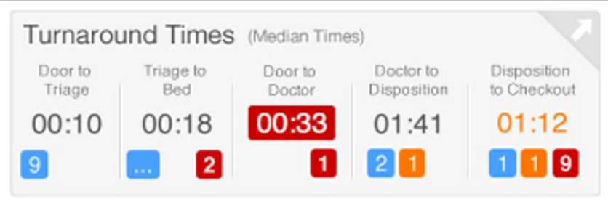

Displays up to maximum 5 tracking event metrics and the corresponding median wait time based on high and critical time thresholds for each metric. Patients below High minute time appear in blue and above this time appear in orange. Patients above Critical minute time appear in red.

Metric examples: Door to Triage, Triage to Bed, Door to Doctor, Doctor to Depart, etc.

Q.2.1.1 What is the Metric 1 name:

Q.2.1.2 What is the Metric 1 High minute threshold:

Q.2.1.3 What is the Metric 1 Critical minute threshold:

Q.2.2.1 What is the Metric 2 name:

Q.2.2.2 What is the Metric 2 High minute threshold:

Q.2.2.3 What is the Metric 2 Critical minute threshold:

Q.2.3.1 What is the Metric 3 name:

Q.2.3.2 What is the Metric 3 High minute threshold:

Q.2.3.3 What is the Metric 3 Critical minute threshold:

Q.2.4.1 What is the Metric 4 name:

Q.2.4.2 What is the Metric 4 High minute threshold:

Q.2.4.3 What is the Metric 4 Critical minute threshold:

Q.2.5.1 What is the Metric 5 name:

Q.2.5.2 What is the Metric 5 High minute threshold:

Q.2.5.3 What is the Metric 5 Critical minute threshold:

## 3 – Acuity and Critical Patients Component

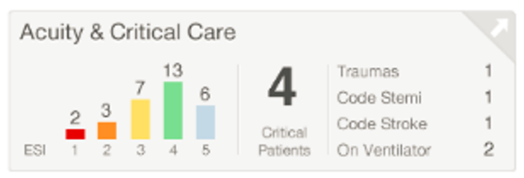

Has two features, first displays the acuity and number of patients assigned to each acuity level in a bar graph format, which come from the tracking board build with the corresponding colours. Second, can define up to 4 optional critical categories for critical patients (from specific tracking event, order, or clinical event (DTA)). Examples: Traumas, Isolation, Infectious, On ventilator, etc.

**If you will use critical categories, answer to the questions below:**

Q.3.1.1 What is the Category 1 Display name?

Q.3.1.2 What is the Category 1 event name (tracking event, order, or event code)?

Q.3.2.1 What is the Category 2 Display name?

Q.3.2.2 What is the Category 2 event name (tracking event, order, or event code)?

Q.3.3.1 What is the Category 3 Display name?

Q.3.3.2 What is the Category 3 event name (tracking event, order, or event code)?

Q.3.4.1 What is the Category 4 Display name?

Q.3.4.2 What is the Category 4 event name (tracking event, order, or event code)?

## 4 – ED Volume Component

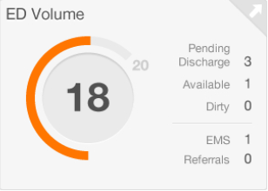

Displays the number of patients relative to the number of beds in the department selected. If the total number of patients exceeds the high threshold the dial turns orange. If the total number of patients exceeds the critical threshold, the dial turns red.

The data in the component excludes patients in the waiting room. The number of patients who have a discharge event requested are considered pending discharge and are displayed to the right of the volume dial. Below that, the component displays the number of available beds and Prearrival.

Q.4.1 What is the high percent threshold for ED volume?

Q.4.2 What is the critical percent threshold for ED volume?

Q.4.3 What is the high minute threshold for pending discharge?

Q.4.4 What is the critical minute threshold for pending discharge?

Q.4.5 What is the total number of available beds in ED?

## 5 – Waiting Room Component

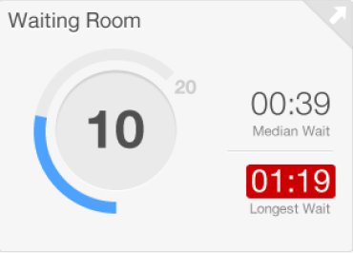

Displays patients in the waiting room locations for each department with the corresponding median wait time and longest wait time.

If the total number of patients in the waiting room exceeds the high threshold, the dial turns orange. If the total number of patients in the waiting room exceeds the critical threshold, the dial turns red.

Q.5.1 What is the high percent threshold for number of patients in waiting room?

Q.5.2 What is the critical percent threshold for number of patients in waiting room?

Q.5.3 What is the high minutes threshold for the waiting room LOS?

Q.5.4 What is the critical minutes threshold for the waiting room LOS?

Q.5.5 What is max total capacity for the waiting room?

## 6 – Pending Admits Component

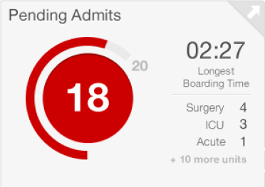

Displays patients in the selected department who have a pending admit event started based on current time. It also displays the longest boarding time of the pending admit patients, and optionally if configured the breakdown of admit services.

When the number of patients who are pending admission exceeds the high threshold, the dial turns orange. When the number of patients who are pending admission exceeds the critical threshold, the dial turns red.

Q.6.1 What is the high percent threshold for number of pending admits?

Q.6.2 What is the critical percent threshold for number of pending admits?

Q.6.3 What is the high minutes threshold for the pending admits boarding time?

Q.6.4 What is the critical minutes threshold for the pending admits boarding time?

Q.6.5 Optional -What is the admit order to capture admitting service or type?

Q.6.6 Optional -What is the admit order to capture admitting service or type?

## 7 – NEDOCS (National Emergency Department Overcrowding Scale) Component

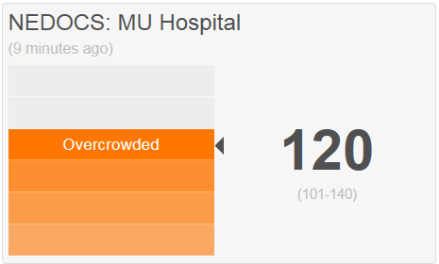

Is a scoring system designed to assess and quantify the level of ED overcrowding at the current moment in time and displays a calculation of the overcrowding score of the Emergency Department?

**If you use NEDOCS in ED, answer to the questions below:**

Q.7.1 What is/are the tracking event(s) used to identify patient bed assignment?

Q.7.2 What is the number of ED published bed for patient care in ED?

Q.7.3 Optional -What are the list of event codes to identify patients on Ventilators?

Q.7.4 Optional - What are the list of orderable to identify patients on Ventilators?

Q.7.5 Optional - What are the number of licenced inpatient beds for hospital in which the ED is associated?

Q.7.6 Optional – What is the score that will trigger the high alert notification?

Q.7.7 Optional – What is the score that will trigger the critical alert notification?

Q.7.8 Optional – What are the user group code values from HNA user group for the list of people who should receive the first-tier alert when NEDOCS score has surpassed the critical threshold?

## 8 - Pending Orders Component

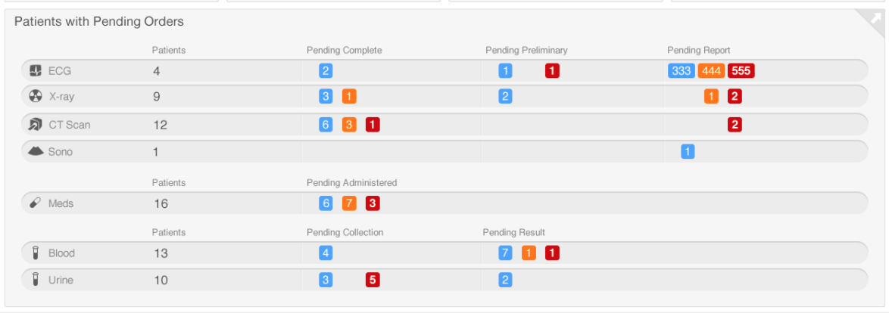

Counts the number of patients who have active orders in the following areas – XRay, CT, ultrasound, medications, blood, and urine orders. It displays the number of patients within each order area in the process column they qualify for.

**Q.8.1.1 What are blood orderable in ED?**

Q.8.1.2 What are blood orderable exclude in ED?

Q.8.1.3 What is the blood collection High minute threshold?

Q.8.1.4 What is the blood collection Critical minute threshold?

Q.8.1.5 What is the blood resulted High minute threshold?

Q.8.1.6 What is the blood resulted Critical minute threshold?

**Q.8.2.1 What are the CT orders in ED?**

Q.8.2.2 What is the CT Complete High minute threshold?

Q.8.2.3 What is the CT Complete Critical minute threshold?

Q.8.2.4 What is the CT Report High minute threshold?

Q.8.2.5 What is the CT Report Critical minute threshold?

**Q.8.3.1 What are the XRay orders in ED?**

Q.8.3.2 What is the XRay Complete High minute threshold?

Q.8.3.3 What is the XRay Complete Critical minute threshold?

Q.8.3.4 What is the XRay Report High minute threshold?

Q.8.3.5 What is the XRay Report Critical minute threshold?

**Q.8.4.1 What are the Ultrasound orders in ED?**

Q.8.4.2 What is the Ultrasound Complete High minute threshold?

Q.8.4.3 What is the Ultrasound Complete Critical minute threshold?

Q.8.4.4 What is the Ultrasound Report High minute threshold?

Q.8.4.5 What is the Ultrasound Report Critical minute threshold?

Q.8.5.1 **What are the Urine Test orders in ED**?

Q.8.5.2 What are the Urine Test exclude orderable?

Q.8.5.3 What is the Urine collection High minute threshold?

Q.8.5.4 What is the Urine collection Critical minute threshold?

Q.8.5.5 What is the Urine resulted High minute threshold?

Q.8.5.6 What is the Urine resulted Critical minute threshold?

**Q.8.6.1 What are the meds exclude orders?**

Q.8.6.2 what is the meds admin High minute threshold?

Q.8.6.3 what is the meds admin Critical minute threshold?